Literature meets Great American Art:
The Amstud Mash-up
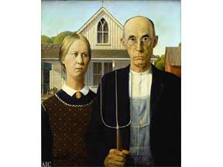
In very general terms, art can be divided into two major types: representational art, or art that attempts to re-create faithfully the images found in the world around us; and abstract art, or art that attempts to get to the essence of the world around us but not imitate the images.

Your Task: Find one companion piece of great art by a well-known American artist (gallery-worthy!) that represents, either symbolically or thematically, some aspect of a book you have read this year. Choose from either representational or abstract art, but be prepared to submit both a printed copy of the art and a typed analysis of the visual image and its connection to the novel. Please be sure to follow these guidelines:
- Written component must be typed, double-spaced, and include an appropriate MLA heading (if you don’t know what this is, look it up!)
- Your analysis must include the artist and title of the work in addition to a full explanation of how the art connects to your novel.
- Due: SEPTEMBER 19, 2016

